INDIAN SCHOOL AL WADI AL KABIR
Class: X | Department : Computer Science | Year :2023-2024  Date of Submission: 09/08/2023
Holiday Homework | Topic: AI project cycle
Q1. Select a theme from the the structure given below. Listout the problems in a topic related to the selected theme. Make a problem statement for any one problem.
(Refer to the example with agriculture as a theme, which has diccussed in the class)
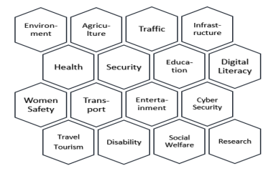
Q2. List down any five data visualization techniques that can be used in the data expolaration stage of AI Project cycle. Use the table format (given below) to describe each techniques
